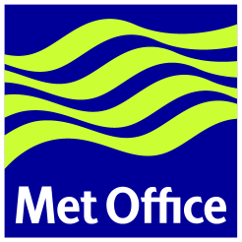
14th US-Europe Data Exchange Meeting

Met Office College, Shinfield Park, Reading U.K.
16-18 May 2001

Draft Agenda

Wednesday 16 May 2001
09:00 Welcome (J. Eyre)
09:05 Approval of agenda (All)
09:10 NESDIS status reports (V. Tabor)
10:10 NCEP status report (R. Petersen)
10:40 Coffee break
11:00 Meteorological Service Canada status report (G. Verner)
11:30 EUMETSAT status report (S. Elliot)
12:00 MétéoFrance status report (B. Lacroix/H. Roquet)
12:30 Lunch in college restaurant
14:00 Deutscher Wetterdienst status report (T. Böhm)
14:30 ECMWF status report (H. Böttger/J-N. Thépaut)
15:00 Coffee break
15:30 Met Office status report (R. Saunders)
16:00 OSO telecomms report (F. Branski)
16:30 Met Office telecomms report (D. Tinkler)
19:30 Meeting Dinner at Colleys Supper Rooms in Reading as guest of Met Office
(dress smart casual, no jeans)

Thursday 17 May 2001
09:00 Review of actions from 13th meeting
10:30 Coffee break
11:00 Review of U.S. requirements (R. Petersen)
12:30 Lunch in college restaurant
14:00 Review of European requirements (H. Böttger)
15:00 Coffee break
15:30 Continue discussion of European requirements

Friday 18 May 2001
09:00 Draft actions available for review
09:30 Review of actions
10:30 Coffee break
11:00 Review format of meetings and membership
11:30 Plans for next meeting
12:00 Close of meeting

